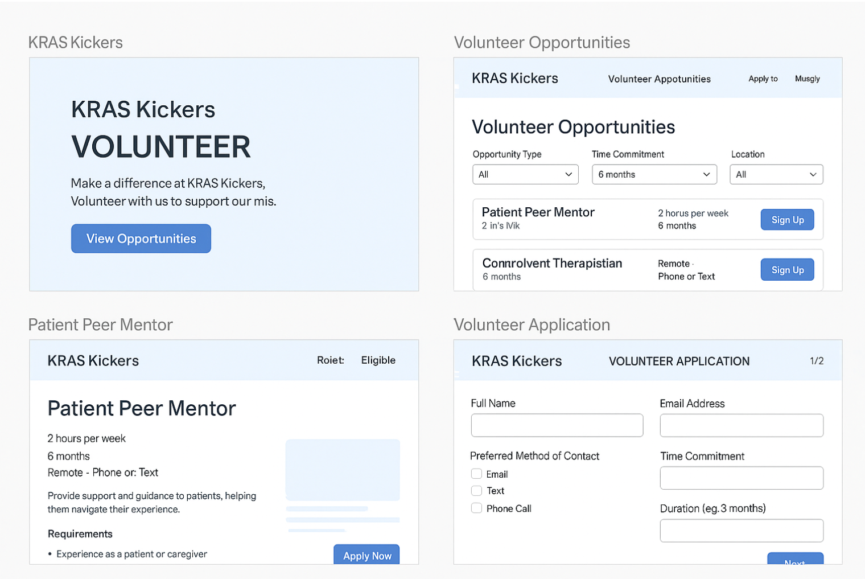

**Step A. Discover volunteer opportunities**

* Volunteer lands on a “Volunteer Opportunities” page for KRAS Kickers.
* They see a **list** of current opportunities: each listing shows *role name*, *short description*, *time commitment*, *duration*, *mode of contact*, *location / remote or in-person*.
* They can filter by e.g. “role type” (patient voice, care partner support, clinician peer mentor, advocacy work), “time commitment” (e.g. <2 hrs, 2-4 hrs, ongoing weekly), “mode” (remote/phone/in-person), maybe “duration” (one-time, recurring, x weeks).

**Step B. Volunteer expresses interest / signs up**

* On each opportunity listing there’s a “Sign up” or “Apply” button.
* The volunteer is prompted to fill a simple form:
  + Name, contact info (email, phone number, text preference)
  + Preferred mode of contact (email / text / phone)
  + Which roles they are interested in (you could allow them to choose from options or type their own)
  + Preferred time commitment (e.g. “I can give 2 hours/week for 6 months” or “I can give 5 hours total this month”)
  + Duration they are comfortable with (e.g. one-time, 3 months, ongoing)
  + Skills/experience or type of volunteer work they’d like (free text or pick from list)
  + Availability (days/times)
  + Any special considerations (remote/in-person, travel, accommodations)
* Upon submission, they get a “Thank you – we’ll be in touch” confirmation.

**Step C. Organization review & assignment**

* Someone at KRAS Kickers (volunteer coordinator) receives the application.
* They review the applicant’s stated availability, interests, preferred mode of contact and match to an opportunity.
* They send a follow-up via the volunteer’s preferred contact mode: e.g. “Here’s the role we’re proposing, here’s the schedule, please confirm you can commit by date X.”

**Step D. Onboarding / orientation**

* Once confirmed, the volunteer gets onboarding: this might include a welcome packet/page:
  + Summary of role, expectations, contacts, schedule
  + Any training materials (if needed)
  + A point of contact (name/phone/email)
* Volunteer logs the first session / activity.

**Step E. Volunteering happens**

* Volunteer engages in the role as scheduled.
* There’s a simple system (or even manual) to record that they showed up/participated and how many hours.

**Step F. Feedback & recognition**

* After a certain number of sessions or at role completion, send a feedback form: “How was your experience? What could we improve?”
* Also send recognition: certificate of service, “thank you” email/social mention, hours logged summary.

**Step G. Renewal / next steps**

* After finishing a role, volunteer should be invited to pick another one or continue.
* Maintain a volunteer database with interests/time commitments so you can reach out when new roles open.

**. Design / UX Outline**

I’ll specify some key pages/screens and fields. You can hand this off to a web dev/designer.

**A. Volunteer Opportunities Listing Page**

* Hero banner: “Join us. Make a difference with KRAS Kickers.”
* Search/filter bar: filter by role type, time commitment, remote/in-person.
* Listings: each item shows
  + Role title (e.g. “Patient Peer Mentor”)
  + Time commitment (e.g. “2 hrs/week”)
  + Duration (e.g. “6 months”)
  + Mode (e.g. “Remote – phone or text”)
  + Short description (one or two lines)
  + Button: “View Details / Sign Up”

**B. Opportunity Details Page**

* Role title, full description: what you’ll do, who you’ll work with (patients / care partners / clinicians)
* Requirements/skills (if any)
* Time commitment & duration clearly stated
* Contact mode (e.g. “We’ll communicate by email and text”)
* Locations (if in-person) or remote instructions
* What you’ll gain (experience, connection, recognition)
* Button: “Apply Now”

**C. Application Form Page**

Fields (with friendly labels):

* Full name
* Email address
* Phone number
* Preferred mode of contact (checkbox: Email / Text / Phone call)
* Which role(s) are you interested in? (dropdown or multi-select list) + “Other (please describe)’” field
* Time commitment you are comfortable with (dropdown: e.g. “<1 hr”, “1-2 hrs/week”, “3-5 hrs/week”, “I’ll commit X hours total this month” etc)
* Duration you are comfortable with (dropdown: “One-time”, “3 months”, “6 months”, “Ongoing”)
* Days/times you are available (free text or checkboxes for days of week + morning/afternoon/evening)
* Remote vs in-person preference (radio buttons)
* Skills / experience / special interest (free text)
* Additional comments or accommodations needed
* Submit button.

**D. Confirmation / Thank You Page**

* “Thank you for submitting your interest. We’ll review your info and get back to you within X days via your preferred contact method.”
* If you like, include a link: “Return to Opportunities”.

**E. Volunteer Dashboard (optional but nice)**

* If you expect many volunteers, you could have login-access for volunteers:
  + View your current assigned role(s)
  + See upcoming schedule
  + Log hours (or confirm attendance)
  + View your past service, hours, recognition
  + Update your profile (availability, contact preference, skills)
* But if you want simplicity you could skip the login part and manage more manually.

**F. Admin/Coordinator Panel (for KRAS Kickers)**

* A simple backend list of volunteer applications: columns for name, contact info, preferred contact method, interested roles, availability, status (new, reviewed, assigned)
* Ability to assign volunteers to roles and send out communication
* Track volunteer hours, send recognition.

**G. Responsive/Mobile Design**

* Ensure pages are mobile-friendly (many volunteers may sign up on phone).
* The “Apply” button should always be visible and prominent.
* Use clear typography, accessible colours, friendly tone.

**H. Visual & Content Style**

* Use warm, inclusive images (patients, clinicians, care partners volunteering).
* Friendly voice: “Your time matters”, “Join our community of voices”.
* Emphasize what the volunteer does *and* why it matters — helps motivation.
* Use icons or badges for time commitment, remote/in-person, duration.
* Provide FAQs: “Do I need experience?”, “Can I volunteer remotely?”, etc.

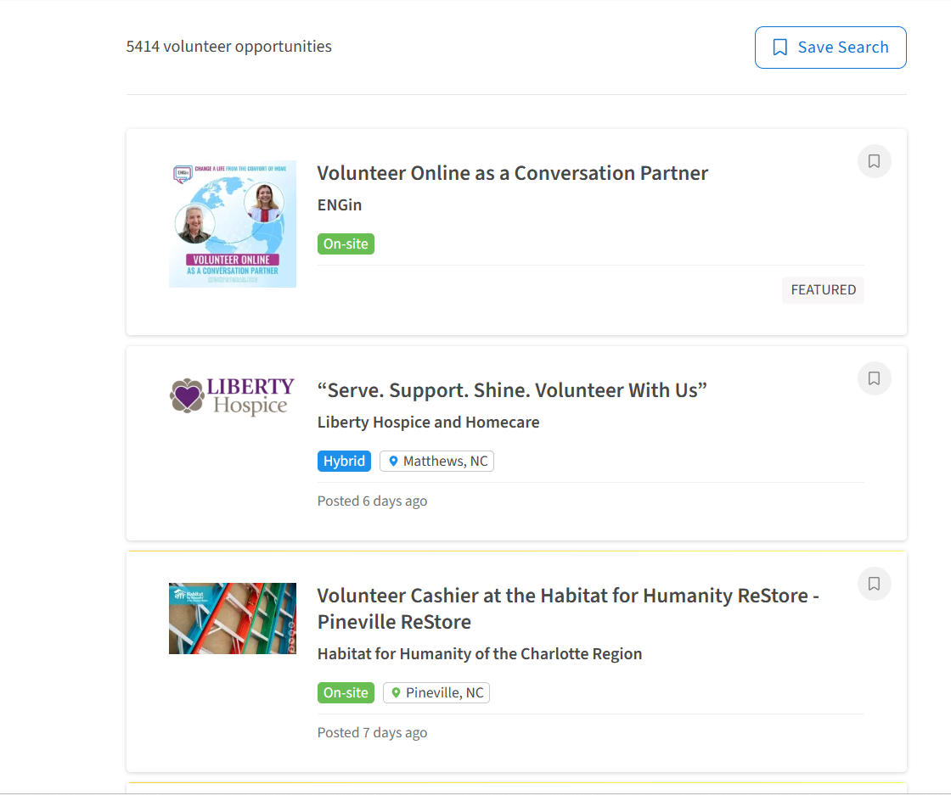

<https://matthewshelpcenter.org/support-local-families-in-financial-crisis/volunteer/>

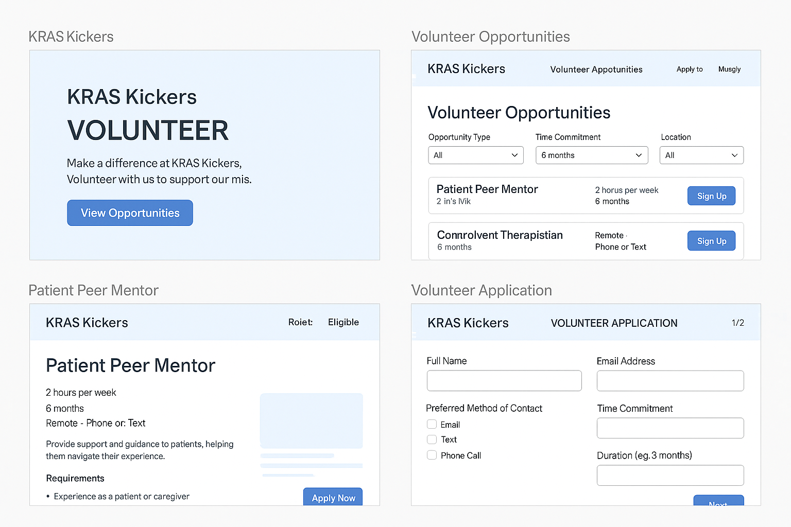

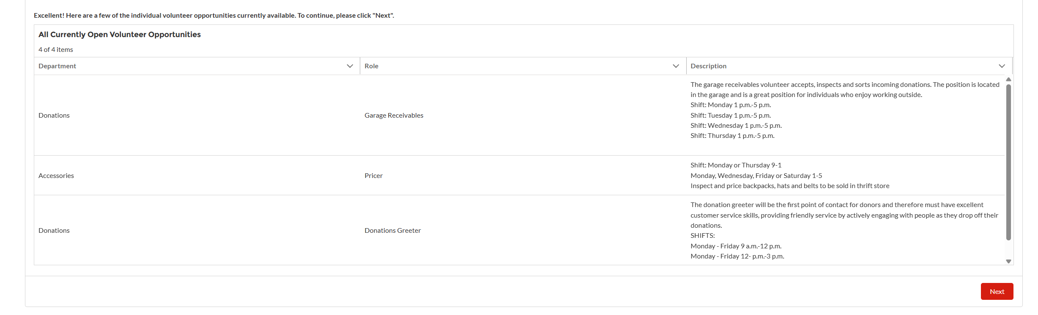

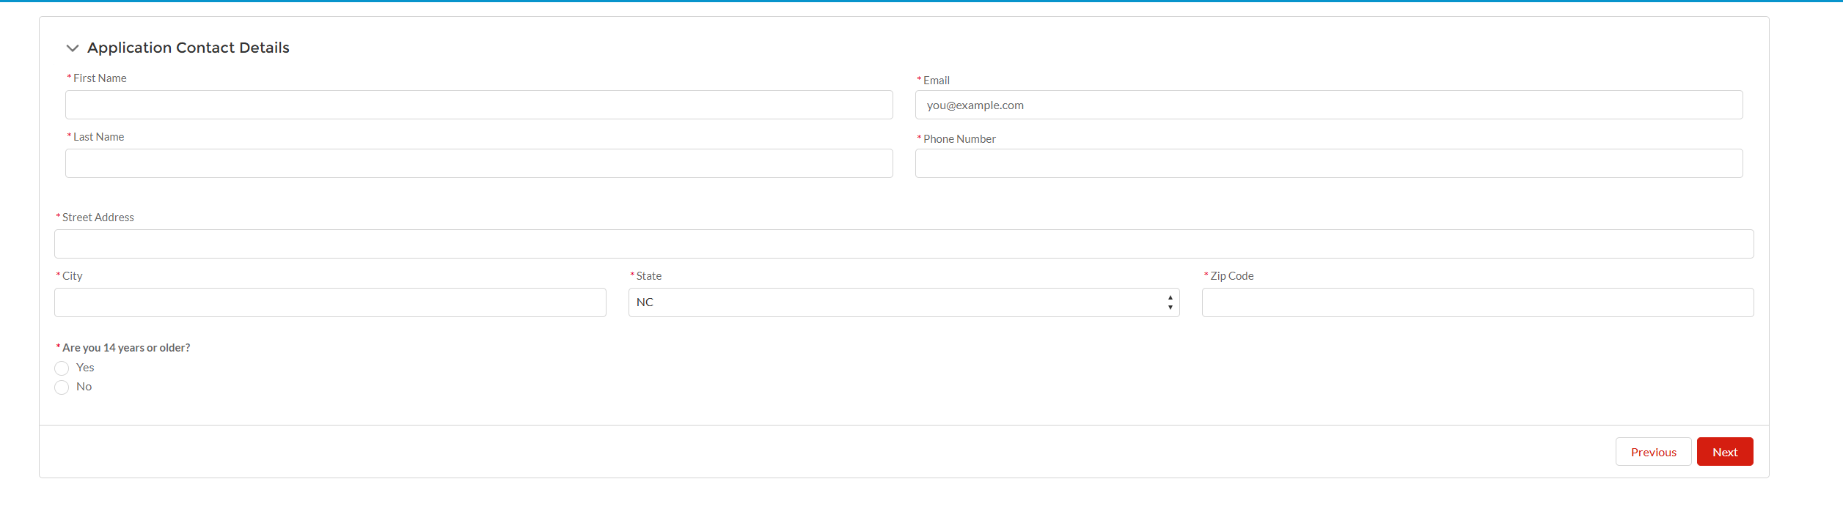

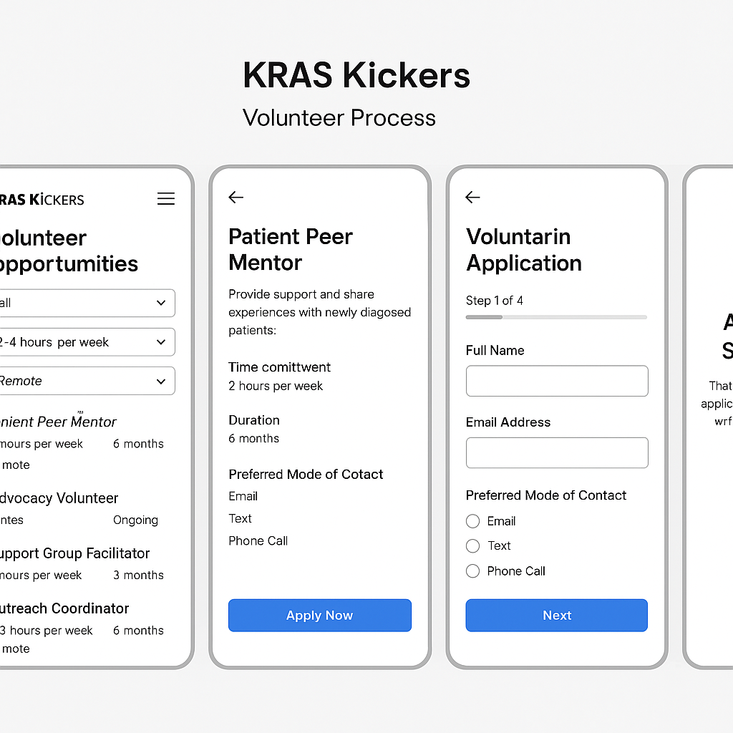

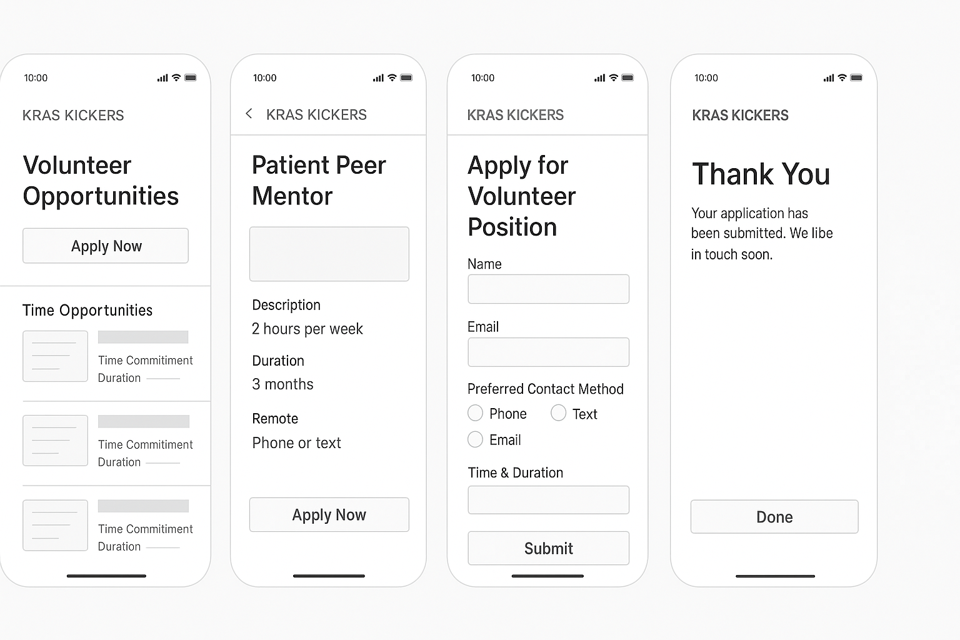

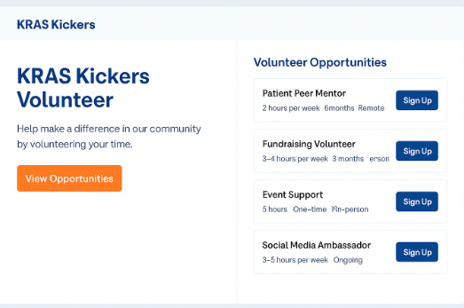

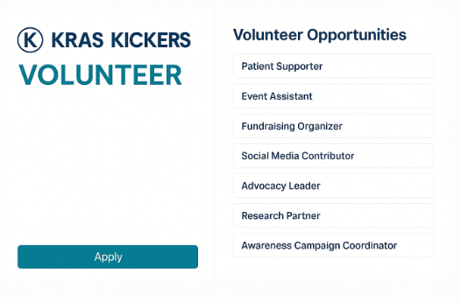

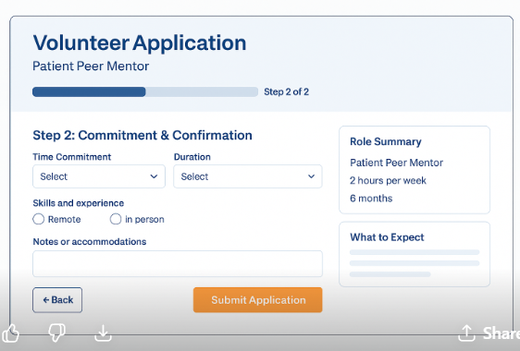

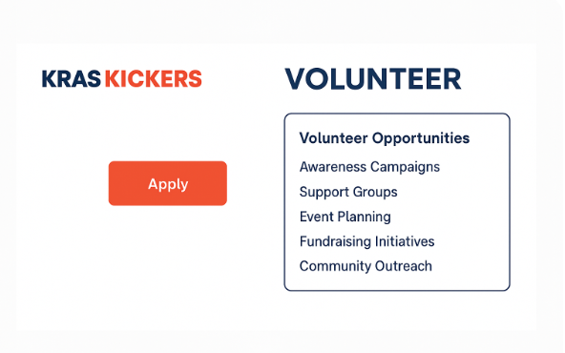

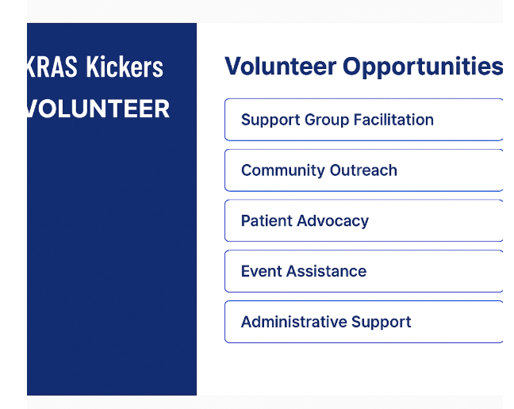

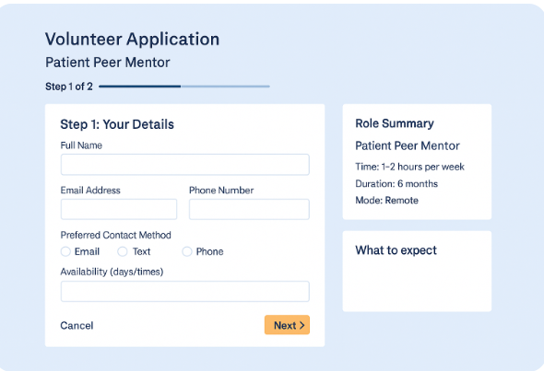

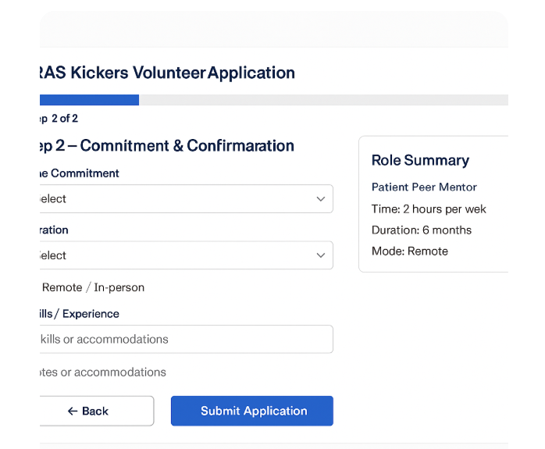

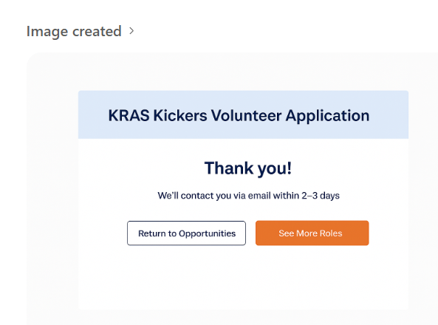

┌───────────────────────────────┬──────────────────────────────────┐

│ Left Panel (40%) │ Right Panel (60%) │

│───────────────────────────────│──────────────────────────────────│

│ 🟦 KRAS Kickers Volunteer │ Volunteer Opportunities │

│ │ -------------------------------- │

│ [Form Title] │ ▢ Patient Peer Mentor │

│ Step 1 — Your Details │ 2 hrs/week · 6 months · Remote│

│ │ [Apply → Autofill Left Form] │

│ Full Name: [______________] │ -------------------------------- │

│ Email: [______________] │ ▢ Community Outreach │

│ Phone: [______________] │ 3 hrs/week · 3 months · Hybrid│

│ Preferred Contact: │ [Apply → Autofill Left Form] │

│ ( ) Email ( ) Text │ -------------------------------- │

│ │ ▢ Event Assistance │

│ Availability: [___________] │ One-time · In-person │

│ │ [Apply → Autofill Left Form] │

│ [Submit Application] │ │

|  |  |
| --- | --- |
|  |  |